

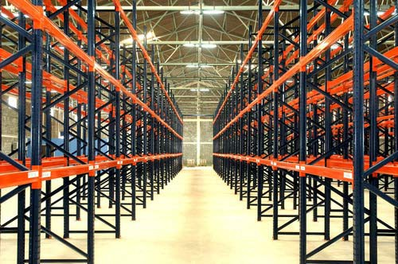

GSS Design Configurator
Design Rules Document - 1

Note : The information in this document has been gathered based on our current knowledge. It is important to note that this document may not be exhaustive. Godrej is expected to add more points during the discovery phase.

Contents
- Introduction 3
  - Purpose 3
  - Scope 3
- Elevation system 4
- Elevation details by customer 5
- Elevation selection based on SKU 8
- Elevation selection based on Pallet 9
- Elevation selection based on MHE (Material Handling Equipment) 12
- Rack placement 14
  - Rack Orientation 16
  - Rack Placement near pillars 17
    - Pillar outside unit 18
    - Pillar near half unit 19
    - Pillar inside unit 20
  - Under pass 21
- SPRS Components 22
  - Frame 22
    - Bracing 23
  - Beam 24
  - Stability Components 25
    - Row connector 25
    - Tie beam………………………………………………………………………………………………………………….26
    - Tie rod & Turn buckle……………………………………………………………………………………………….27
  - Safety 27
    - Upright guard (Center column guard) 28
    - Row guard 29
    - Pallet stopper pipe 30
    - Mesh cladding………………………………………………………………………………………………………….31
    - Nylon Net cladding……………………………………………………………………………………………………32
  - VNA Components……………………………………………………………………………………………………………..33
  - Seismic Components………………………………………………………………………………………………………………37
  - DDPR Components…………………………………………………………………………………………………………………39
  - Accessories…………………………………………………………………………………………………………………………….40

Introduction
The Rack Automation project for Godrej involves many design rules. These rules will help the developers to achieve the expected solutions. The design rules that are used for the development of the application includes Rack placement logic, level calculation etc.

Purpose
The purpose of the document is to brief the design rules that are used in the application. It provides guidance and template material which is intended to assist the relevant management or technical staff. It is also useful background reading for anyone involved in developing or monitoring the GSS Design Configurator.

Scope
Following design rules regarding to the GSS Design configurator are explained in the document:
 Elevation system;
 Elevation details;
 Elevation selection based on SKU;
 Elevation selection based on Pallet;
 Elevation selection based on Material Handling Equipment;
 Rack placement;
 Components.

Elevation system
This section explains SPRS Elevation system. It can be briefly explained as:
 A typical elevation in SPRS consists of single faced rows and double-faced rows;
 A typical elevation system is shown below:
1400
140

1000kg |  | 1000kg

1000kg |  | 1000kg

ELEVATION

1000kg

1000kg

1000kg

1000kg

1000kg

1000kg

100
2400 C/C
2310 Clear
100
1200
1000

3000
Clear Aisle
2650
1200 1200
110
Max Unit Height :6762 Upright Height :5900
Last Level :5612
1412
152
1400
140
Upright Height :5900
System Height :5905
SIDE VIEW SIDE VIEW

 Clear aisle should be maintained between the rows to allow MHE and this is based on MHE specifications.
1400
140
 Clear Height will be shown in the elevation.
 First level will be at 50mm pitch + 12mm and all other levels will be at 50mm pitch only. In the above drawing the first level is at 1412mm and all other levels are at 1400mm.
 Multiple elevation types will get generated and placed in the drawing based on roof type and user input rack types.

 

Elevation details by customer
User will be asked to enter the following details:
 Rack Width;
 Rack Depth;
 Rack Height;
 Load per level;
 No of Loading levels;
 Level to level height.

Validations for values entered by user
The user entered values are validated based on MHE specs and SPRS component specs.

Rack Width

Width is validated based on Beam load carrying capacity, no of pallets per level and load per pallet. (discussed in detail in Elevation based on Pallet section). Rack width inner to inner to be maintained as Beam Span + 10mm (Considering the clearance of Lip connector and assembly clearance on both sides)

Rack Depth
Depth is validated between min. 500mm to max. 1500mm. (discussed in detail in Elevation based on Pallet section)

Rack Height
Rack height is validated based on MHE’s MFH (maximum Fork Height) or civil clear height as given below:
Rack height = Last loading level + 250mm/300mm (multiples of 100mm pitch)
Last loading level = minimum of (warehouse clear height – 200mm - Pallet height, MHE working height – 200mm)
Rack height should not exceed height by depth ratio of 6. If exceeds, then additional stability components should be considered. (stability guidelines will be shared)
The depth of the frame can be taken as overall depth of the frame for single sided units. In the case of double-sided units, the depth can be taken as the sum of overall depth of the two double sided frames and the space between them (row connector length).
The height of the system to be considered for calculating height to depth ratio is the height of the last loading level from floor.

Load per level
Load per level is validated based on (no of pallets stored in a level x load per pallet) <= predefined beam load carrying capacity.
(Beam load chart will be shared)

Number of loading levels
Number of levels is validated with Frame load capacity as given below:

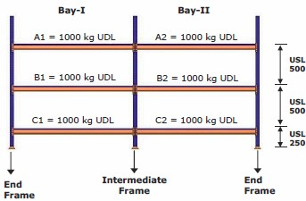
Frame is selected based on the value of load per frame on the respective un‐supported length (USL).
Frame height should not exceed 12000mm (for std configuration & stability guidelines will be shared).
The load per frame on any unsupported length is equal to the sum of the loads on all the levels above that unsupported length (USL).
- A load table is given for GX90 frame (load capacity per USL).
- Load at first USL to be checked for the frame load carrying capacity and second level also to be checked for the frame load carrying capacity. In either of the above, if load is not taking then levels to be reduced accordingly.
- Load at first USL in the above picture is given as:
  - Load at 250 USL is 3000kg (3x1000kg)
- Load at Second USL in the above picture is given as:
  - Load at 500 USL is 2000kg (2x1000kg)
- Total Load acting on the loading levels should not exceed the max total load carrying capacity of the frame.
- The minimum number of loading levels required per system is 1.
  - If the number of loading level is 1, tie rod and turn buckle arrangement should be given to ensure stability (Stability guidelines will be shared)

Level to level height (USL)
 Vertical distance between one beam to next beam / ground to first beam.
 The maximum value is <= 3000mm.

Elevation selection based on SKU
User will be asked to enter the following SKU details:
 SKU Type (Drum/box/bins/gunny bags);
 SKU Width;
 SKU Depth;
 SKU Height;
 SKU Weight;x`
 Stack ability;
 Re‐orientable.

Pallet selection
The pallet that is to be used is determined based on SKU input given by the user as given below:
 Pallet width is based on SKU Width or Depth (Based on re‐orient‐ability);
 Pallet depth is based on SKU Depth or Width (Based on re‐orient‐ability);
 Based on Re‐orientable property of SKU, predefined Pallet Width and Depth has to be used;
 Based on SKU weight and Stack ability, pallet load determined.
 Pallet load = SKU weight X Stack ability X SKU per level (based on best fit orient ability).
  Pallet Load should not exceed 1000 kg.

Elevation selection based on Pallet
The following pallet details are given by user directly (OR) have to be determined based on SKU input.
 Pallet Width;
 Pallet Depth;
 Pallet Height (Over all height with SKU);
 Pallet Load;
 Pallet Type (only Runner supported);
 Pallet Height: 150 mm.

Frame depth
Based on pallet depth, frame depth is determined

 Frame depth is determined based on Pallet Depth – 200mm. With allowing of 100mm pallet overhang on both sides (Front and back).
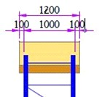

 If Pallet depth is 1200mm, then the Unit depth is 1000mm;
 If Pallet depth is 1000mm, then the Unit depth is 800mm.

Beam
The beam is selected based on Pallet input.
 Based on pallet load and no of pallets accommodated, the total load on each level is determined;
Load on each level = No of pallets per level * load per pallet
 Load on each level should be less than selected beam max load carrying capacity
 Based on load on level, beam with higher load capacity is determined.

Note: Combinations of pallets are used to determine the maximum beam load utilization.

Placing of racks
Following are the design rule that are followed while selecting and placing the racks:
 Clear distance of minimum 75mm/100mm should be maintained between pallets (please refer below image for clear distance for different beams/pallets used);
 Pallet overhang of 100mm (min 50mm & max 150mm) allowed in depth side;
 The depth of the system is arrived based on the pallet depth;

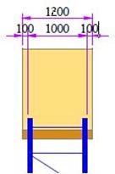
 The width of the system is based on no of pallets per level;
 1, 2 or 3 pallets per level can be placed depending on the pallet width and weight of the pallet as shown in the image below:

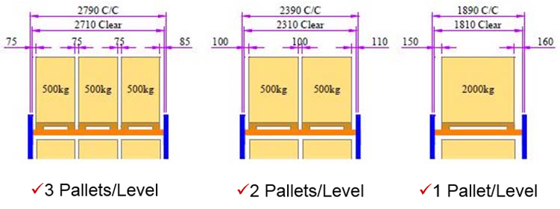

 The system height is arrived based on the no of levels, pallet height, beam section and clearance between the pallet top and beam bottom;
 The overall height (pallet + SKUs) should be less than or equal to 1500mm;

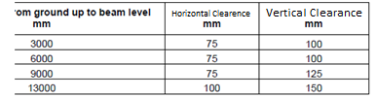
Note: The Clearances mentioned in the above table are gap / clear horizontal distances between pallets and vertical clear distance between top SKU and its above beam.
Horizontal clearance of 75mm is used only for 3 no of 800mm pallet case. For other pallet width combinations 100mm horizontal clearance is used.
 Upright height should be increased to minimum of 250mm or 300mm in last loading level to get multiples of 100mm in upright height.

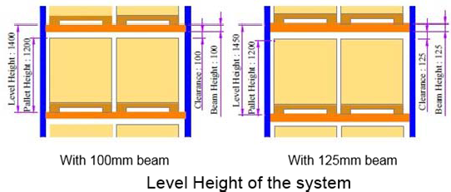

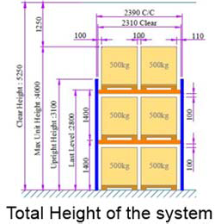

Elevation selection based on MHE (Material Handling Equipment)

MHE’s used for SPR
The following MHEs are suitable for SPR:
 Stacker
 Fork lift
 Articulated fork lift
 Reach truck

Rules Used
The following rules should be maintained:
 Pallet l oad carrying capacity should be less than the Load carrying capacity at MHE's MFH (from MHE data entered or chosen by user).
 Clear / Working aisle used for rack placement should not be less than the MHE Working aisle (from MHE data entered or chosen by user).
 Last loading level height should be MHE's MFH height – 200mm;
 Clearance of 100mm to be maintained between the wall and frame for sides & between pallet and wall on backs for stacker, forklift & reach truck. But for articulated forklift, Clearance of 500mm to be maintained between the wall and frame for sides & 100mm between pallet and wall.
 Clear aisle in Underpass (between two row guards) is based on MHE cross aisle (from MHE data entered or chosen by user);

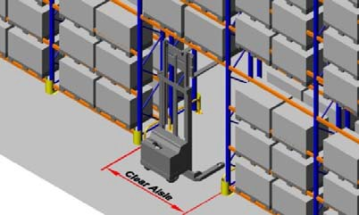
 Clearance of 100mm should be present under beam (between beam bottom and mast / collapsed height of the MHE)

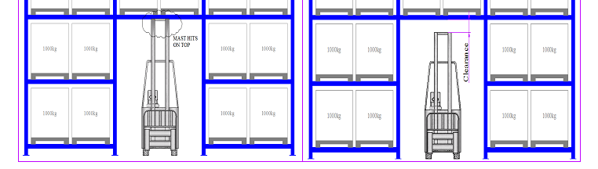
 The Rack height is calculated based on clear height of ware house and MHE's MFH
(if MHE exists) as given below:
Rack height = Last loading level + 250mm/300mm (multiples of 100mm pitch)
Last loading level = minimum (warehouse clear height – 200mm - Pallet height, MHE working height – 200mm)

Default MHE values
If the user selects the option as Existing MHE and user selects the MHE type in UI then the default MHE values based on the MHE type selected like MFH, Load at MFH, Working Aisle, Cross Aisle and Overall Height lowered / Collapsed height values will be automatically filled (which are already defined in database)
If the user selects the option as MHE to be suggested then following rules to be followed.
 MHE selection based on Clear Height:
      - MHE is selected based on Clear Height (given by user).
      - MHE is selected in such a way that MFH value (given in table) will not be more than Clear Height – 200mm - Pallet Height
      - Pallet load (given by user) should be less than MHE’ load at MFH (given in table).

 MHE selection based on System Configuration:
      - MHE is selected based on rack last loading level height (given by user)
      - MFH value (given in table) should be more by 200mm than the rack last loading level height (given by user)

      - Pallet load (given by user) should be less than MHE’ load at MFH (given in table).
 MHE selection based on MHE type:
      - User will choose the MFH type (Stacker/Forklift/Articulated forklift/Reach truck)
      - MHE is selected based on Pallet load (given by user).
      - For Example, the MHE values are 500kg, 750kg, and 1000kg loads at MFH.
      - If Pallet load is 600kg we have to choose MHE of 750kg load at MFH.
      - Pallet load should be less than the load at MFH.

Note : The various MHE types and the values will be shared later.

Rack placement
Typical Selective Pallet Racking Layout is shown in the image below:

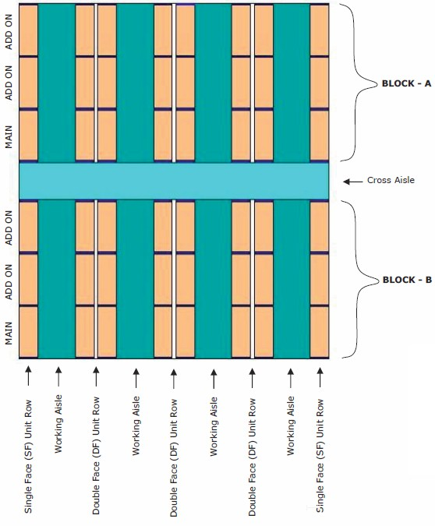
 Clear aisle, Picking aisle and working aisle are same (it is parallel to rack placement).
 Cross Aisle and transfer aisle are same and it is perpendicular to rack placement.

 Only Single face unit and double face units are considered.
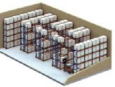

 Working Aisle and Cross Aisle are based on MHE input (from MHE data entered or chosen by user).

 Cross Aisle is automatically placed if continuous rack placement length exceeds 20m to 25m.
 Cross Aisle is placed/positioned at middle of continuous rack placement in a row.
 Minimum number of units required in a row is 2. This rule is applicable only for SF row standalone units & DF row standalone units and not for DF row back side row connector connected units.

A typical layout consists of walls, shutters, pillars, working path etc.

WALL
SHUTTERS

A typical layout with SPR units. (Only SF and DF considered)

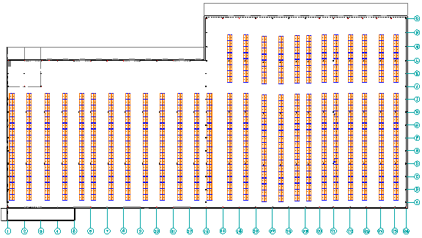

Rack Orientation

Three different options should be available in the UI for selecting the orientation of the rack in the layout.
- Auto;
- Horizontal;
- Vertical.
The Auto options should give the best fitting orientation for the given layout. This also gives the user the layout with maximum capacity, orientation and less cost. The following things are considered while giving the Auto orientation:
- Maximum capacity to be accommodated;
- Best fitting orientation;
- Minimum cost (Number of Main units should be less).
When user gives the rack orientation as Auto, racks will be placed perpendicular to the door entrance in the layout as shown in the image below:
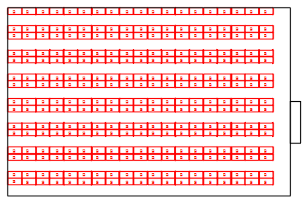
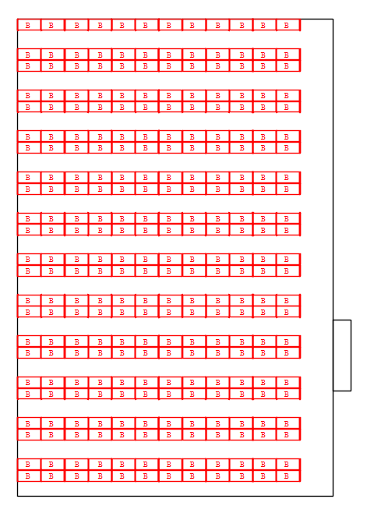
Horizontal and Vertical options available in the UI gives the user a privilege to decide the orientation of the racks according to his choice.
When any of these option is selected:
- After every 15m, there should be a passage (this is not shown in the images);For example if the length of the row is 30m then the passage should be in the middle (i.e. close to after 15m), If the length of the row is 19m then also the passage should be at the middle and not at 15m.
- Door will play a major role in deciding the clear aisle;
- Aisle path distance from the wall will be same as the clear distance captured in the requirement capturing.
- Clear aisle should be maintained from the wall with door;
- Clear aisle will also be maintained from walls perpendicular to the doors.
When the User is doing manual layout, the software can give proper prompts/caution notes in case the above rules are not met.

Rack Placement near pillars
When pillar come as obstacle in SPRS racks placement following solutions can be used based on situation.
 Pillar outside unit;
 Pillar near half unit;
 Pillar inside unit.

Pillar outside unit
When pillar is obstructing rack placement and if pillar is directly interfering beam or frame components and the remaining distance between pillar and adjacent rack is less than the size of half unit, then we can omit that rack at that position.
As the following picture shows, the beam is directly interfering with pillar.

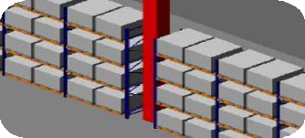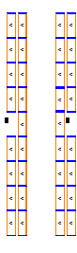

We have to omit the rack in following situations:
 Beam directly interfering with pillar;
 Frame directly interfering with pillar;
 Half unit (Smaller sizes of rack) is not possible at remaining portion (from pillar to adjacent rack).
 A minimum gap of 100mm should be maintained between beam & pillar;

Pillar near half unit
When pillar is obstructing rack placement and it is directly interfering with beam or frame components, then we have to check whether any half unit can be placed at reaming distance between pillar and adjacent rack. If enough space exists for half unit, then we have to place a half unit as add‐on to adjacent unit.
As the following picture shows the beam directly interferes with pillar.

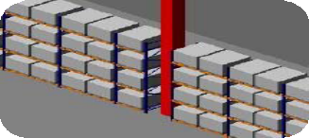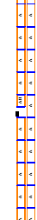

We have to place half unit for following situations:
 Beam directly interfering with pillar;
 Frame directly interfering with pillar;
 Half unit (Smaller sizes of rack) is possible at remaining portion (from pillar to adjacent rack).
 A minimum gap of 100mm should be maintained between beam & pillar;

Note: If we call main unit as A, then the half unit should be called AH.

Pillar inside unit
When pillar is not obstructing rack placement and pillar is not directly interfering with beam or frame components and it is inside the rack placement (Exists completely between frames and beams), then we can continue placing racks leaving the pillar inside as it is.

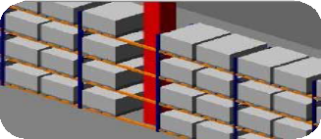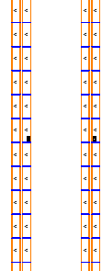

We can continuously place SPR racks ignoring pillar for following situations:
 Pillar is not interfering with Beam directly ;
 A minimum gap of 100mm should be maintained between beam & pillar;
 Pillar is not interfering with Frame directly;
 Pillar is not interfering with any other SPRS components;
 Pillar completely exists within rack system.

7.3 Under pass
In SPRS system for movement of MHE we have to remove some beams placed at ground level.
 We have to place underpass units where MHE path is marked perpendicular to rack placement;
 Clear aisle in Underpass (between two row guards) is based on MHE cross aisle;
 Under pass clear height below beam should be based on MHE mast height (or) collapsed height of the MHE
 Under pass clear height below beam should be more by 100mm than MHE mast/collapsed height of the MHE



Note: If main unit is called A, then under pass unit should be called AU.

SPRS Components

Frame
Two vertical members connected by a set of cross members constitute a frame. Frame is the vertical load bearing member of the pallet racking system.
Each frame consists of:

 Two uprights
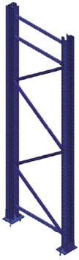

 Two base plates (Refer the stability guidelines 20250918 GSS Stability Guidelines for SPR.pdf document for more details)
 Two Grouting/Anchor bolts (M12x100) per base plate;
 Two Hex Bolts & nuts - Base plate to Upright (M8x25);
 SHIM ‐ Metal plate beneath base plate;
 Two shims per base plate;
For GXL90 & GXL 110 – 2Nos of 1.4thk shim (60% of all base plates)
For GXL120 – 1No of 1mm thk shim and 1No of 2mm thk shim (70% of all base plates)
 Horizontal and diagonal bracings (D-bracing & X-bracing based on load)
 Bracing spacer (Ø17 x 29 x 5)
 Stiffener and Bottom stiffener (Based on load chart)
 Front and rear splice (Beyond 12m upright height)

The frame selection is based on the total load of the system (Load per level x No. of levels) and the maximum USL of the unit.

(Upright load chart will be shared)

Bracing
Bracings are the cross members that connect two uprights together (horizontally & diagonally) to form a frame.

 Hex Bolts M10x75 used to connect bracing to frame on both
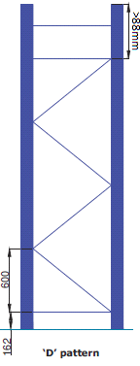

ends.
  Bracing spacer to be considered where the 2 bracings are not there at the nodes;
 The next bracing starts from the same hole and both of them are bolted.
 The top last horizontal bracing has to be provided @ min of 88mm from the top of the upright.
 If the top horizontal bracing is above the last loading level and the gap between the top horizontal bracing and the upright top is less than or equal to 250mm then additional top horizontal bracing is not required.
 If top horizontal bracing to upright top level is more than 250mm and less than 550 mm then one more horizontal bracing to be placed as shown in picture else top horizontal bracing is not required.

Beam
Beam is the horizontal load bearing member of the pallet racking system. Two beams mounted on the front and rear upright of the frame at same level forms the support structure for pallet loading.
 Every beam is provided with a pair of beam locking pins.


Beam design is based on span and load level (Explained in 5.2 beam section).

(Beam load chart will be shared)

Stability Components

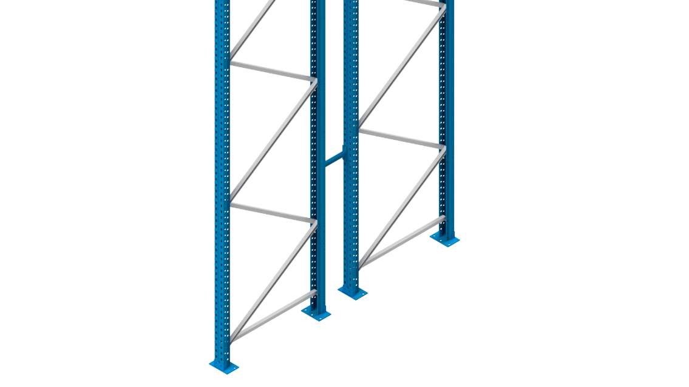
Row connector

Row connector
Row connectors are used to connect two single‐faced units back to back to form a double‐faced unit. Row connectors are used when the height to depth ratio exceeds the safe limit. Refer to guidelines for the usage of row connector.

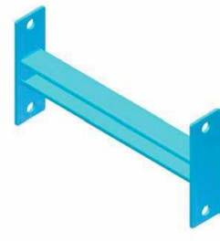

 4 numbers of M10x25 Hex Nut and Bolt with plain washer used to connect uprights;
 Row connectors are placed at 2000mm pitch vertically;
 First row connector has to be placed at 1300mm from bottom;
 Last row connector has to be placed at 150mm from top.
 Row connectors are placed between two frames in double faced row
 Row connector and pallet stopper should not intersect with each other and pitch should not exceed 2000mm.
 Row connector and loading level beam should not intersect with each other and pitch should not exceed 2000mm.

Tie Beam

Tie beams are stability members used to connect units on either side of an aisle together to ensure stability of taller units. These are upright profiles fixed to frames by tie beam support bracket on either end.
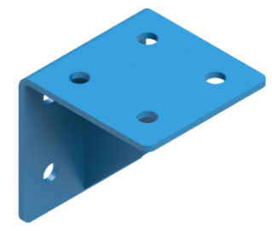
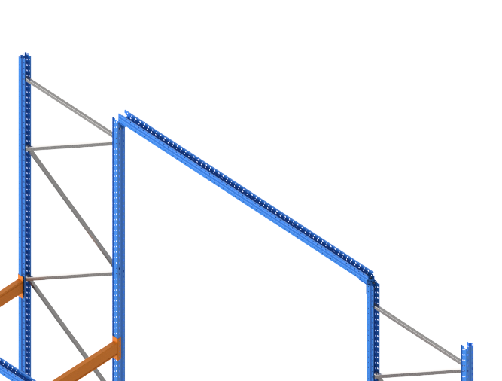

The location of these tie beams in layout is decided based on the H/D ration, which is mentioned in the stability guidelines.

This stability guidelines document will be shared separately.

Tie rod & Turn Buckle

Tie rod assembly is used to ensure stability of the system in down aisle direction. Turn buckle in the assembly ensures tension in the tie member. Flat end M10 turn buckle is used.
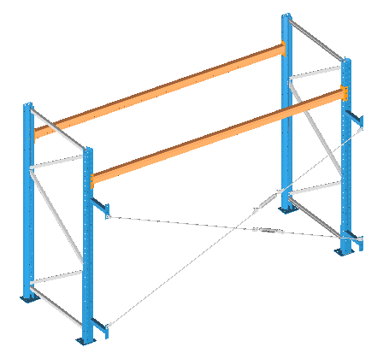
The location of these tie rods in layout is decided based on the stability guidelines.

This stability guidelines document will be shared separately.

These tie rods are connected to frames using SF/DF row connectors.

(Stability guidelines will be shared)

Safety
The following picture shows placement of safety components like upright guard and row guard.

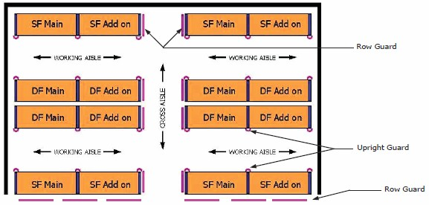

Upright guard (Centre column guard)
Upright guards are provided in front of each upright along the working aisle and fixed firmly to the floor with 3 numbers of grouting bolts.
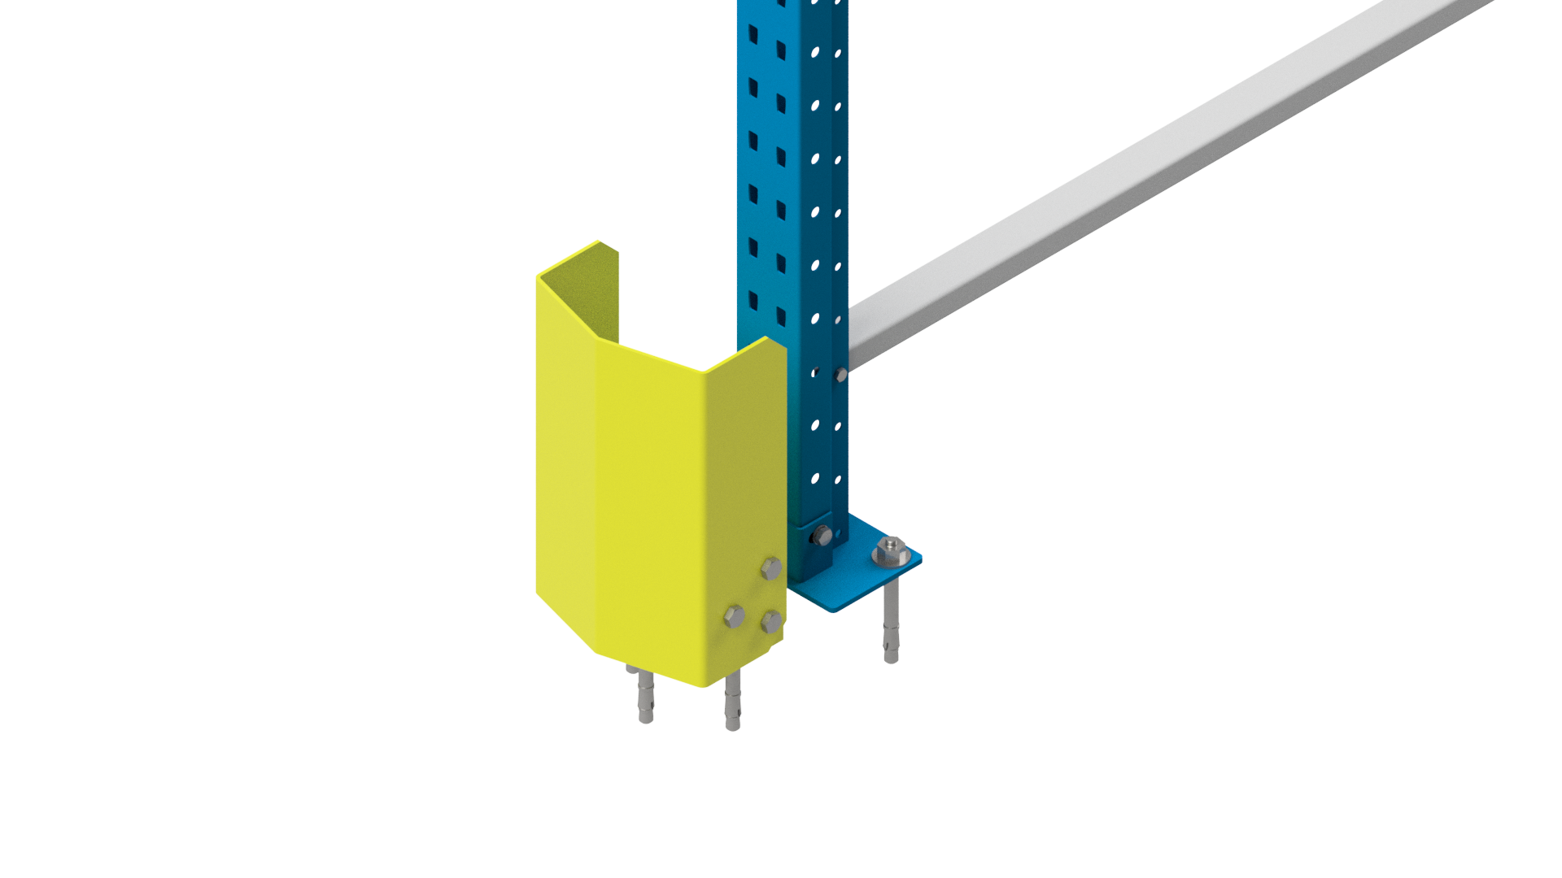

The size of the grouting bolts used to fix this guard is M12x100. 3 no’s of M12x100 grouting expansion bolts required per guard.

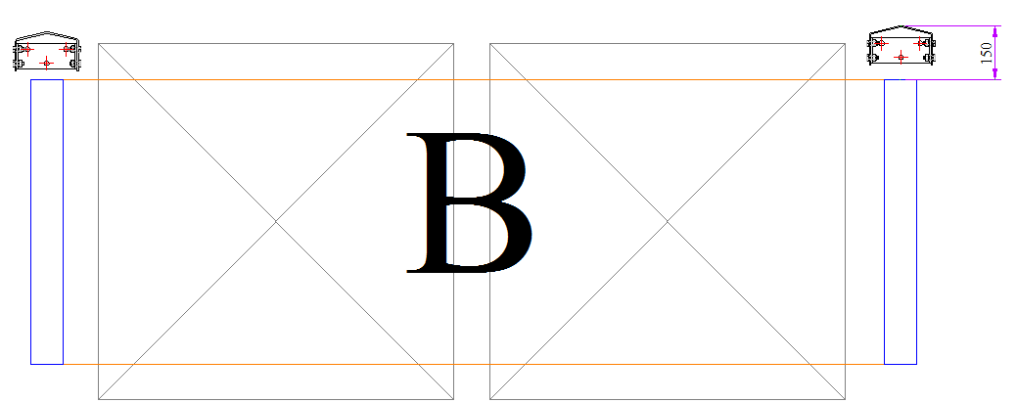

Row guard
Row guards are used to protect end frames exposed to cross aisles and also the front face of the uprights when the end row of units are exposed to an open area where the MHE movement is possible.

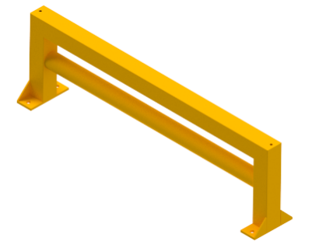
 4 no’s of M12x100 grouting expansion bolts per row guard is required;
 The selection of Row Guard depends on the Frame Depth.

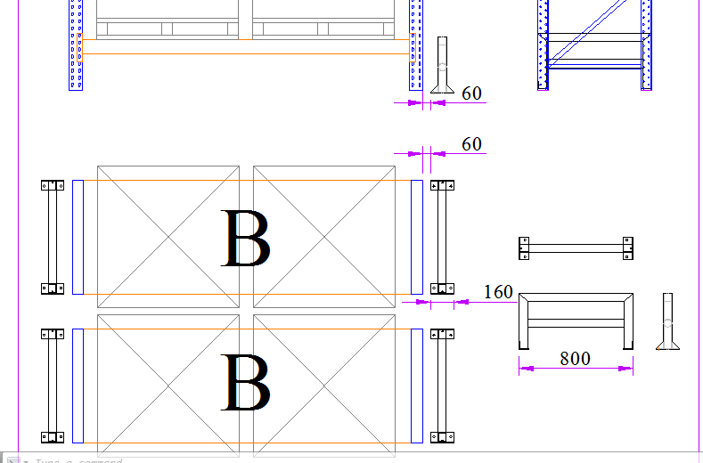

Pallet stopper pipe
Pallet stopper is provided to restrict the movement of the pallet behind its limits while loading.
Pallet stopper pipe is placed on back side of Single faced row and between double faced rows (to any one row back side).
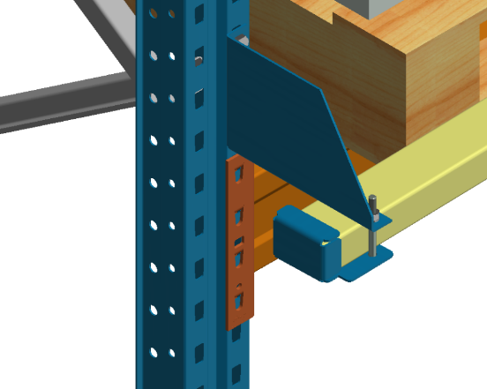

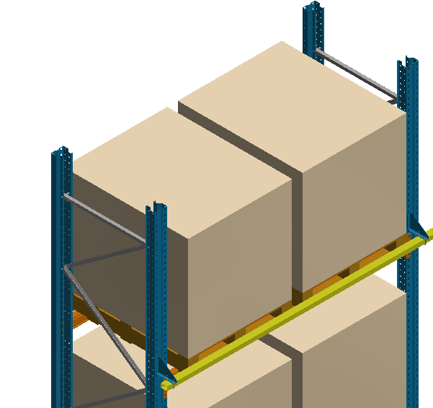

The ends of the pipe is plugged with end clamp.
 This will be calculated based on length of each row and no of levels required; 2 no of end clamps are placed for every row ends.
 This will be an accessory, not a default member; will be given based on user requirement.
 Extra clamps to be provided if under pass units or pillars are given in a row considering the layout and elevation configuration.
 The pallet stopper quantity should be calculated based on No. of levels per unit. If the no. of levels is different or the USL is different in both the units of DF, then quantity calculation should be separately done for each unit in DF.

Mesh Cladding

Mesh Claddings (or) Weld mesh Claddings are provided in the system to clad the sides of the SF & DF end units and rear sides of SF unit to avoid material falling to the aisle and also for secured material storage.

The rear mesh is tubular frame design, having 19x19x1.2thk tube frame, inside which 50x50 grid 3dia wire mesh is welded.

It is fixed to upright using mesh frame clamp. The clamp length will varies w.r.t overhang of pallet.

The side mesh is without tubular frame, has both ends welded with flats over which it is bolted to upright side face.

The side meshes grid also 50x50 & 3dia wire.
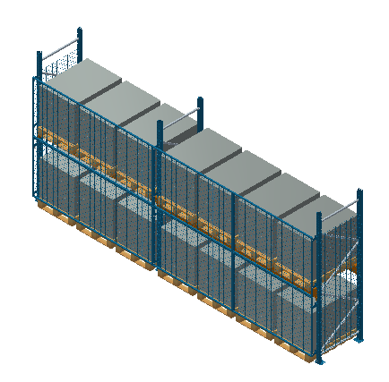
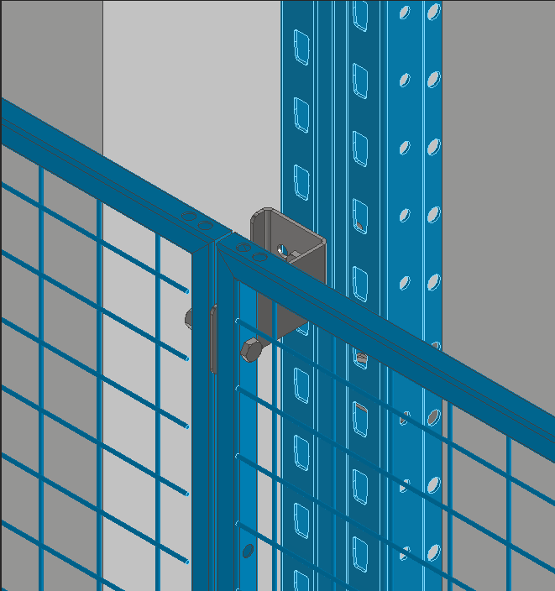
Rear Mesh Mesh clamp (For fixing rear mesh)

Rear Mesh:
Width = Upright C/C-3mm
Height – 495m to 1195mm @ 50mm pitch
Side Mesh:
Width = Frame depth-11mm
Height – 495m to 1195mm @ 50mm pitch
(Mesh cladding height combination document will be shared)

Nylon Net Cladding

Nylon netting minimizes the potential of racking products falling off the back of pallet racks. Nylon net is edged with polypropylene rope for ideal operation. Nylon net design is considered for flush mounting on pallet racks for optimum results.
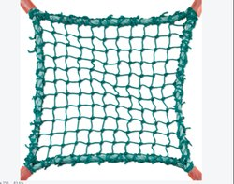

Nylon net cladding comes with a grid size of 25.4 x 25.4 mm, with a mesh wire of Ø 2.5 Single Braided rope.
It is tied with rope on to the upright or to a row connector using Cable ties.
Logic will be shared later

VNA Components

Whenever the system is used with very narrow aisle equipment, set of guide rails will be provided along the system to guide that equipment.
A guide rail set consists of
Entry guide rails (LH & RH),
Outer guide rails,
Inner guide rails,
Intermediate guide rails
Balance guide rails

Entry Guide Rail
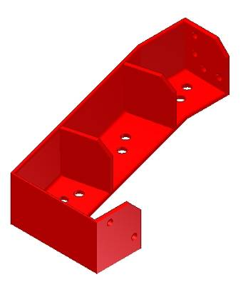
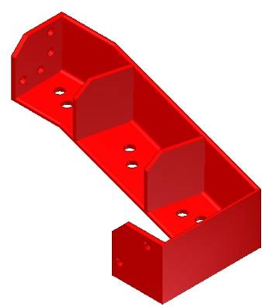
‘LH’ TYPE
‘RH’ TYPE

The Entry Guide rail is an ISA 100x100x10 section, welded with gusset plates as a rigid block. This Guide Rail will be subjected to a maximum load of 25kN, parallel to floor, as the VNA truck enters the working aisle. Hence this rail is grouted to the floor using M16 chemical anchor bolt – 4 nos. per rail. The overall size of the Rail is 500x300mm.

Outer Guide Rail

The Outer Guide Rail is an ISA 100x100x10 section. The rail length could be anything less than 3m and welded with plates at two ends for rail to rail connectivity as shown in the fig.111. This guide rail acts as a guard for the end frames, when the VNA truck is operating in the cross aisle. This rail is grouted to the floor using M16x150 mechanical torque type bolt at a pitch of 500mm (Approx.).
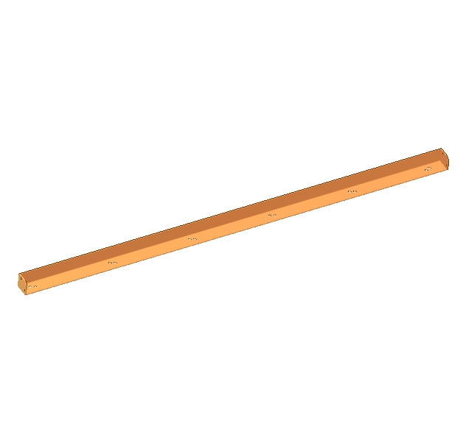

Guide Rail (Inner, Intermediate, Outer & Balance)

Inner Guide Rail

The Inner Guide Rail can be any one of ISA 50x50x8 section, ISA 65x65x8 section or an ISA 100x100x10 section. The section will be selected based on the VNA Truck to be used. The rail is of length 3meter (fixed) and welded with plates at two ends for rail to rail connectivity. this rail is grouted to the floor using M16 chemical anchor bolt – 10 nos. per rail at a pitch of 320mm (Approx.).

Intermediate Guide Rail

The Intermediate Guide Rail can be any one of ISA 50x50x8 section, ISA 65x65x8 section or an ISA 100x100x10 section. The section will be selected based on the VNA Truck to be used. The rail is of length 3meter (fixed) and welded with plates at two ends for rail to rail connectivity. This rail is grouted to the floor using M16x150 mechanical torque type bolt – 6 nos. per rail at a pitch of 570mm (Approx.).
Balance Guide Rail

The Balance Guide Rail can be any one of ISA 50x50x8 section, ISA 65x65x8 section or an ISA 100x100x10 section. The section will be selected based on the VNA Truck to be used. The rail length could be anything less than 3m and welded with plates at two ends for rail to rail connectivity. This Guide rail is grouted to the floor using M16x150 mechanical torque type bolt at a pitch of 500mm (Approx.).

Factors to be considered while selecting Guide rail section

Following are the factors to be considered while selecting the section for Inner, Intermediate & Balance guide rail.

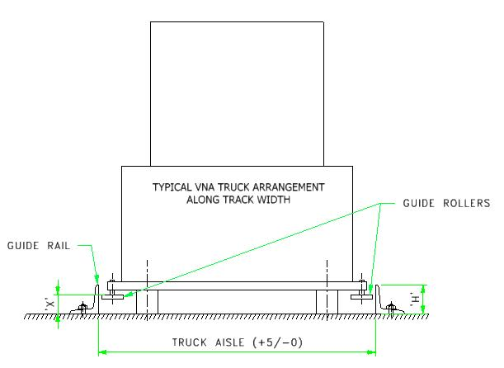
Distance between the floor and Truck Guide Roller Top surface (marked as Dimension- ‘X” in below fig.)

The Distance between the floor and the truck guide roller top surface will vary from one model to the other. Guide roller position for some VNA truck models will be shared later.

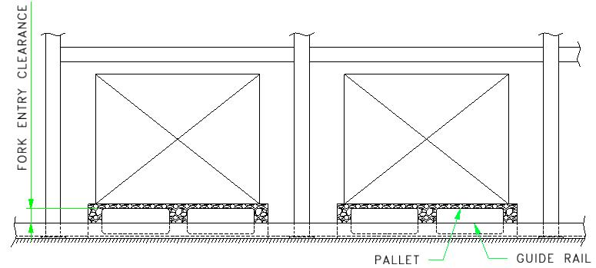
Condition for providing bottom beam,

Pallets loaded on ground should have sufficient fork entry clearance over the Guide rail as shown in above image. One way to create sufficient fork entry clearance is to increase the pallet resting floor level to the rail height. If the floor level cannot be increased, bottom beam shall be provided at the required height as shown below.
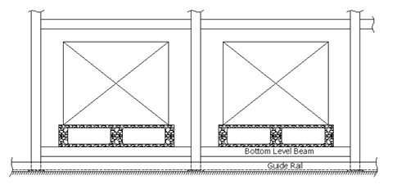

Seismic components

Whenever the SPR system is supplied to a Seismic location, set of components will be provided to ensure stability during seismic conditions.
Plan Bracing
Back bracing

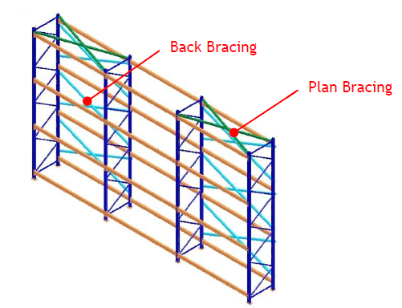

- Procedures for Seismic Design

- Verifying the seismic zone as per zone map or enquiry input.
- If zone up to 4, sections are selected from the Seismic load chart.
- In case of zone 5, the sections should be manually entered by the user.
- In Elevation Plan bracing locations to be mentioned i.e. in which level plan bracing to be given.
- In layout Back bracings locations to be showed i.e. in which units, the back bracing to be given.
Note: Guidelines for Seismic back bracing and plan bracing locations will be shared. And the Load chart for Seismic Zone 3 & 4 will be shared separately.

- Care to be taken while providing Seismic Design
- Back Bracing Assembly
  - While providing Back Bracing, in DF & SF side row connector length should be checked.
  - For SF row connector, Horizontal tube to be given.
  - 50mm to 100mm gap should be maintained from Back Bracing to pallet.
  - While providing pallet stopper, the back bracing locations should not be provided with pallet stopper pipe.
  - In case of both will come, the clearances between Pallet stopper pipe and the Back Bracing should be checked.
  - In case of Rear mesh used in the Back Bracing locations, special clamps should be used for mesh.
- Plan Bracing Assembly
  - While providing Plan Bracings, the fasteners should not project out of the beam.
  - In case of GTPS or PSB used in the loading levels, the Plan bracing to GTPS hindrances should be checked. If the Plan Bracings hindrance with the GTPS or PSB, increase the beam size to next section.
- Baseplate Assembly:
  - While designing seismic racks, the Base plate thickness increased and also 4 holes are provided.

(Seismic load chart will be shared)

DDPR components

DDPR – Double Deep Pallet Racking is a SPR system where pallets are stored two deep back-to-back, so each row can hold two pallet deep before the Aisle.

The most common used MHE for DDPR system is Double deep reach truck, as shown below.

All the rules are same as SPR system, only that the SF will have 2 rows and a DF will have 4 rows of units, connected to each other using row connectors.

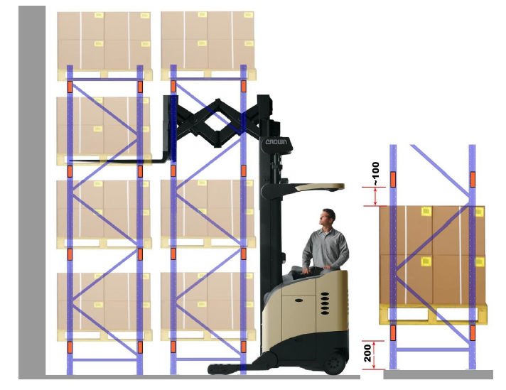
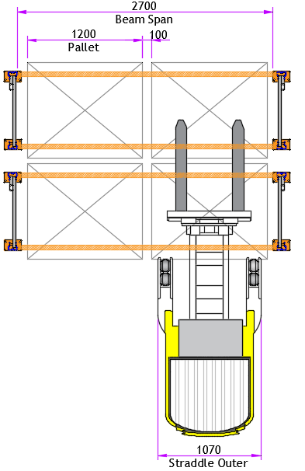

In the case of double deep system, ensure that the reachability of the fork is good enough to handle the second pallet. In double deep system, ground clearance of 200mm has to be provided if the MHE used is with straddle.

Accessories

Accessories are the additional & optional features to the Racking system.
The Racking system accessories are,

Pallet Support Bar
Welded type Pallet Support Bar
Guided Type pallet Support
Fork Entry Bar
6B Panel Decking for Pallet
6B Panel Decking for Shelving
4B Panel Decking for Pallet
Mesh Decking for Pallet
Grating Decking for Pallet
Drum Cradle
P&D station

Pallet Support Bar

The Pallet Support Bar-‘L’ x Thk is a six bend profile formed by bending process. PSB’s are available in four different thicknesses viz. 1.6, 2, 2.5 or 3.15mm. ‘L’ denotes the length of the pallet support bar. The distance between two PSB depends on the width of the pallet.

(Load chart will be shared)

Welded type Pallet Support Bar

The Welded Pallet Support Bars are generally used in conjunction with GTPS, where formed type pallet support bars cannot be used because of their level difference above beam. It is a lipped channel section (1.6, 2, 2.5 or 3.15mm) welded with 2.5mm thick brackets on either side.

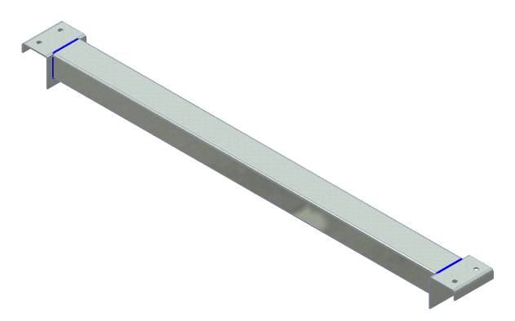
Lipped C-section
2.5thk Bracket welded

(Load chart will be shared)

Guided Type pallet Support

Guided type pallet supports are used,
i. When pallets with post type legs are to be loaded on rack.
ii. When non-reversible pallets of different depths to be loaded on rack.
GTPS is available in four different thickness viz. 1.6, 2, 2.5 or 3.15mm. GTPS can be provided with or without stoppers as per requirement.
When non-reversible runner type pallets are used and when the middle leg of the pallet has to be supported, GTPS is used along with the welded type PSB in the middle. The GTPS and PSB are connected together with Pair of multiflex angle to maintain their relative position. And also GTPS without PSB also connected by pair of MF angles as shown below.

Fork Entry Bar

Fork entry bars are needed when the SKU to be stored on the rack does not have any provision for fork to enter in. It is made by welding together, a main channel, two channel-50mm long and two catwalk support brackets. The 50mm long channel welded between main channel and catwalk support bracket provides the clearance for the fork of MHE to enter and lift the SKU. The distance between two fork entry bars depends on the pallet width.
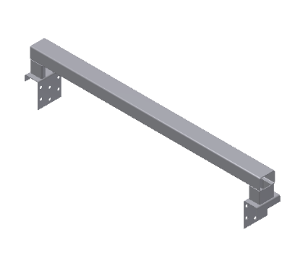
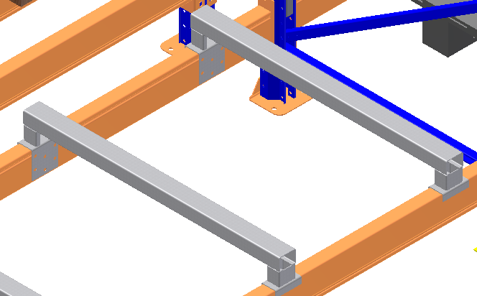
Fork Entry BAR
Position on System

(Load chart will be shared)

6B Panel Decking for Pallet

The panel sectional profile formed by 6 bends is said to be a 6-Bend Panel. It is a Mild steel panel having in thickness 1.25 & 1.60mm (for pallet decking) and width 300mm max and length applicable as per requirement.

The sequences of 6B panel arranged on a beam is said to be a 6-bend panel decking. The number of panel per deck is based on Load carrying, Beam span, panel spacing and panel width.

(Load chart will be shared)

6B Panel Decking for Shelving

In SPR, there will be scenarios where few levels at the bottom will be used as shelving levels, whereas the top levels will be for pallet applications.

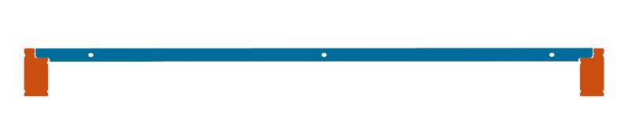
Hence, the 6 Bend panel for Shelving applications are used in these levels with GSB (Step Beam) Beams, having thickness 0.6, 0.7 & 1mmand width 300mm max.
GSB Beam
6-Bend panel for Shelving level
(Load chart will be shared)

Mesh decking for Pallet

The Decking surface formed using weld mesh having welded stiffeners is said to be a weld mesh decking. This decking is a cost effective solution, where as material content per decking level is very less compare to panel decking. The mesh used for weld mesh decking is generally 50x100mm grid dia 4/5mm and ends are bent to lock on a beam. The stiffeners are of tubular or sheet metal profiles; number of stiffeners per deck is based on load carrying and maximum pitch of 500mm.

Note: Logic for mesh decking will be shared later.

Grating decking for Pallet

This decking is used especially for higher Point load carrying capacity requirements. Gratings are brought-out item fitted over GB & Hem+ beams.
There are two types of gratings suitable for Pallet decking level;

(i) Grating with Angle Collar, (ii) Grating with Notching Collar.

Note: Logic for grating decking will be shared later.

Drum Cradle

Drum cradles are used in SPR system when the SKU to be stored is cylindrical, for example drum. The drum cradle holds the SKU in position while stored on beam. This is made by welding two ISA 65x65x6 mm thick angles on a 2.5 mm thick channel. The length ‘L’ depends on the diameter of the drum.

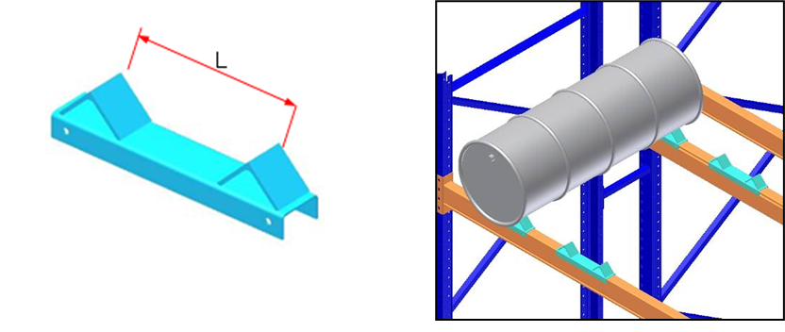

P&D station

In SPR, sometime , the interaction between the Working aisle and the warehouse operating space is taken care by a P&D Station.

The pallet from SPR system is picked by an equipment and deposited in the P&D station from where another equipment picks the pallet and takes it to other warehouse operations and vice versa.

P&D station is made by standard ISMC welded with brackets which are mounted on the uprights. The ISMC used here is also serves as a loading beam at the last unit. The extended portion of the ISMC is cross braced using a C section.

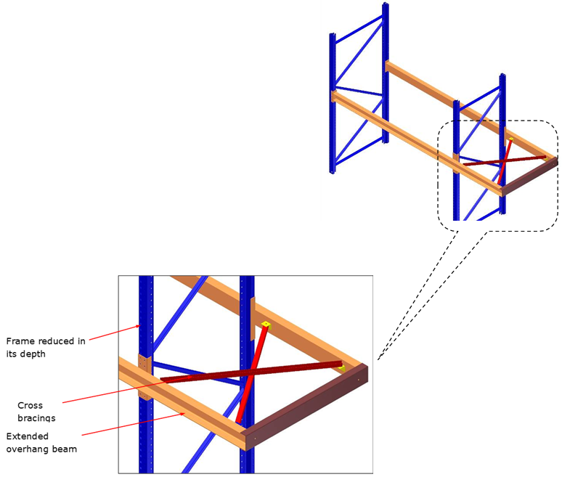

(Load chart will be shared)

